Analyzing Client Satisfaction and Service Utilization at the Dempsey Center
Authors: Min-Hsin Chang, Ziyue Shen

Introduction
The Dempsey Center is a nonprofit that provides free support services to people affected by cancer in Maine. Since opening, they've offered counseling, support groups, complementary therapies like massage and acupuncture, movement programs, and educational workshops. The goal is to help people deal with the physical, emotional, and social challenges that come with cancer.
Every year, Dempsey runs a client survey to see how satisfied people are, what's working, and what needs improvement. We analyzed four years of these surveys, from 2022 through 2025, which yielded more than 1,100 responses for analysis. We focused on three main questions:
- Has client satisfaction gotten better over these four years?
- What factors actually predict whether someone will be highly satisfied?
- Are there different groups of clients with different needs?
The purpose of this analysis is to provide the Dempsey Center with data-driven insights that can inform program improvement and resource allocation. If we can figure out what makes clients happy and how different groups engage with services, Dempsey can make better decisions about where to put their resources and how to improve their programs.

Background
Cancer affects more than just physical health. A 2024 review in eClinicalMedicine found that cancer patients worldwide face significant unmet psychosocial needs, including emotional distress and social isolation, which directly impact their quality of life and health outcomes (Gao et al., 2024). However, access to support services remains inconsistent, and many patients who could benefit from these services are unaware of them.
A 2021 scoping review in PLOS ONE evaluated psychosocial cancer support programs and found that these services can improve well-being and successfully address distressing concerns for both patients and their families (Sautier et al., 2021). The review also emphasized that measuring client satisfaction is important for understanding service quality and identifying where improvements are needed.
The Dempsey Center's approach addresses cancer holistically. Instead of focusing only on medical treatment, they offer emotional support through counseling and groups, physical support through complementary therapies and movement programs, and social connection through community activities. The American Cancer Society notes that this kind of comprehensive psychosocial support can improve treatment adherence, symptom management, and overall quality of life (ACS, 2025).
For organizations like Dempsey that operate on limited resources, understanding what drives client satisfaction helps them allocate those resources more effectively. This analysis examines four years of client feedback to identify patterns that Dempsey can use to improve their services.

Methods
A. Data Overview and Demographics
This study analyzes four years of annual client survey data from the Dempsey Center, covering 2022 through 2025. The raw datasets contained 270, 298, 293, and 319 responses respectively, with column counts ranging from 72 to 105 as the survey instrument expanded over time. Total combined responses numbered 1,179 before cleaning.
One major challenge was that column positions for equivalent questions shifted across years. For example, the satisfaction question appeared in column 0 for 2022-2024 but moved to column 4 in 2025 due to the addition of metadata fields. We manually verified each variable's location in each file before extraction to ensure we were pulling the correct data. Table 1 shows the verified column positions for key variables across all four years.
Variable | 2022 | 2023 | 2024 | 2025
Satisfaction | 0 | 0 | 0 | 4
Life Better | 6 | 1 | 1 | 5
Service Frequency | 27 | 22 | 34 | 38
Age | 47 | 54 | 67 | 74
Gender | 49 | 57 | 71 | 78
Cancer Status | 43 | 50 | 63 | 68
Table 1. Variable Column Positions by Year
We extracted six core variables from each year: overall satisfaction with services (rated on a 5-point scale from Very Satisfied to Very Unsatisfied), whether services made life better (Yes/No), service utilization frequency (1 time, 2-5 times, 6-9 times, or more than 10 times), age group, gender, and current cancer status. Treatment stage and household income were also available for some years but not consistently across all four.
After cleaning, the final dataset retained 1,047 rows distributed as 257 from 2022, 262 from 2023, 252 from 2024, and 276 from 2025. This represented 89% of the original data. The demographics of this cleaned dataset are described below.
The age distribution showed that the Dempsey Center primarily serves an older adult population. The 65-74 age group made up the largest share at 385 respondents (36.8%), followed by the 55-64 group at 274 respondents (26.2%) and the 75 or older group at 197 respondents (18.8%). Combined, these three groups accounted for 82% of all respondents. Younger age groups were notably underrepresented, with only 11 respondents aged 25-34 (1.1%) and 63 aged 35-44 (6.0%).
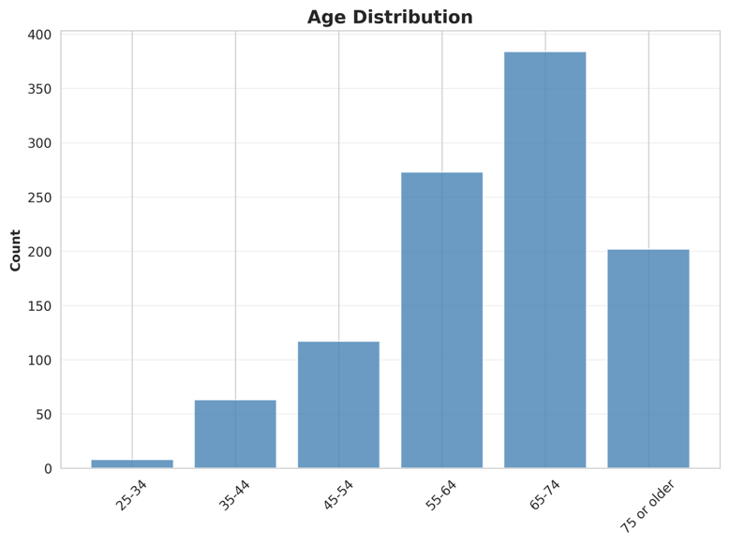
Figure 1. Age distribution of survey respondents.
Gender distribution was heavily skewed toward women, who made up 847 of 1,047 respondents (80.9%). Men accounted for 197 respondents (18.8%), and only 3 respondents (0.3%) identified as non-binary. This distribution remained stable across all four years.
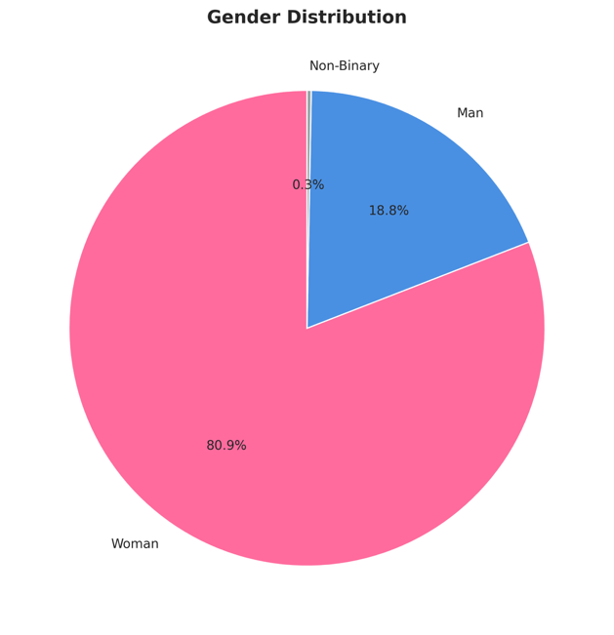
Figure 2. Gender distribution showing 81% of respondents were women.
In terms of cancer status, the largest group consisted of cancer survivors - 406 respondents (38.8%) reported "I have had cancer." The second largest group was current patients at 327 respondents (31.2%). Approximately 17% of respondents were not patients themselves but rather care partners (10.2%) or family members and friends (6.9%) of someone with cancer. The remaining 12.9% selected "Other/prefer to self-describe."
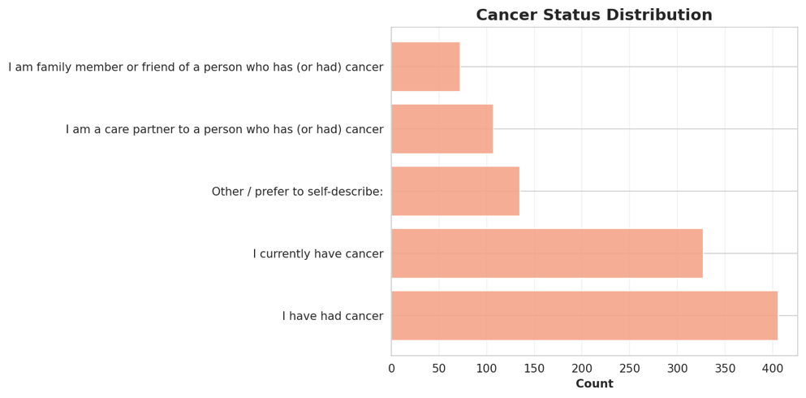
Figure 3. Cancer status distribution showing majority are current or former patients.
Service utilization patterns showed strong engagement. Among the 1,047 respondents, 465 (44.4%) reported using services more than 10 times, making this the most common category. An additional 228 (21.8%) visited 6-9 times, and 281 (26.8%) visited 2-5 times. Only 73 respondents (7.0%) had used services just once. This distribution suggests the center successfully retains clients beyond an initial visit.
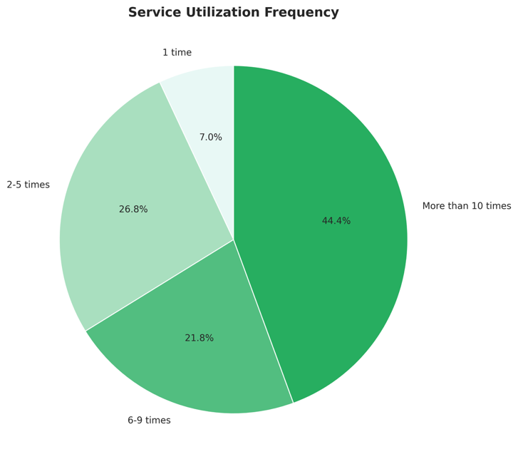
Figure 4. Service frequency distribution.
Response volume remained relatively stable across the four years. The 2025 survey had slightly higher participation (276 responses) compared to the other years, which ranged from 252 to 262 responses. This consistency suggests sustained engagement with the annual survey process.
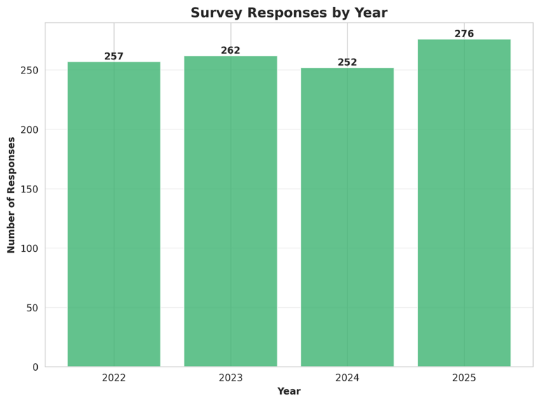
Figure 5. Number of survey responses by year.
B. Data Cleaning
Data cleaning involved several steps to ensure consistency and quality. First, we removed duplicate header rows that appeared in the data. Each Excel file contained a row with the value "Response" that was part of the column headers rather than actual data. We skipped row 0 (the true header) and row 1 (the "Response" row) when reading each file.
Second, we standardized gender labels across years. The 2022 and 2023 surveys used longer labels like "Woman/Female/Feminine" and "Man/Male/Masculine," while 2024 and 2025 used simplified labels like "Woman" and "Man." We converted all to the shorter format for consistency.
Third, we dropped rows with missing values for the two core outcome variables: Satisfaction and LifeBetter. Since our analysis centers on satisfaction, responses without this information couldn't be used. We also removed rows where respondents selected "Prefer not to answer" for Age or Gender, as these demographic variables are key predictors in our models.
The cleaning process reduced the dataset from 1,179 rows to 1,047 rows, representing an 11% reduction. The lost data was primarily from incomplete responses rather than any systematic pattern that would introduce bias.
C. Feature Encoding
Machine learning algorithms require numeric input, so we encoded all categorical variables as integers using sklearn's LabelEncoder. Age groups were encoded in ascending order: 25-34 became 0, 35-44 became 1, and so on up to 75+ becoming 5. Gender was encoded with Woman as 0, Man as 1, and Non-Binary as 2. Service frequency was encoded based on increasing usage: 1 time became 0, 2-5 times became 1, 6-9 times became 2, and more than 10 times became 3. Cancer status was encoded alphabetically from 0 to 5.
We also created a binary target variable called HighSatisfaction for the classification task. Responses of "Very Satisfied" were coded as 1, and all other satisfaction levels (Satisfied, Neither, Unsatisfied, Very Unsatisfied) were coded as 0. This framing allowed us to specifically predict which clients would report the highest level of satisfaction.
D. Statistical and Machine Learning Methods
Chi-Square Tests of Independence. We conducted three chi-square tests to assess whether demographic and behavioral variables were associated with high satisfaction. The tests examined service frequency versus satisfaction, age versus satisfaction, and cancer status versus satisfaction. For each test, we used a significance threshold of α = 0.05. A p-value below this threshold would indicate a statistically significant association between the variables.
Machine Learning Classification. We trained four different classifiers to predict the HighSatisfaction binary outcome using age, gender, service frequency, and cancer status as input features. The four models were Gaussian Naive Bayes (which assumes features follow normal distributions), K-Nearest Neighbors with k=3 (which classifies based on the three closest training examples), Decision Tree with maximum depth of 5 (which creates rule-based decision paths), and Random Forest with 100 estimators and maximum depth of 5 (which averages predictions from 100 decision trees). We set random_state=42 throughout to ensure reproducibility.
We split the data into 70% for training (732 samples) and 30% for testing (315 samples). After training each model on the training set, we evaluated performance on the held-out test set. We also ran 5-fold stratified cross-validation on the full dataset to get a more robust estimate of each model's performance. Stratification ensured that each fold maintained the same proportion of Very Satisfied versus other responses as the overall dataset.
For the tree-based models (Decision Tree and Random Forest), we extracted feature importance scores to understand which variables contributed most to the predictions. We also generated confusion matrices for all models to see how well they distinguished between the two classes.
K-means Clustering. We applied K-means clustering to identify distinct client segments. The input features were age, service frequency, and cancer status, all in their encoded numeric form. We didn't use gender because it showed minimal variation (81% women). To select the optimal number of clusters, we ran K-means for k values from 2 to 10 and plotted the within-cluster sum of squares (inertia) at each k. The "elbow" in this plot indicated where adding more clusters provided diminishing returns. Based on this method, we selected k=4 and ran the final clustering with random_state=42 and n_init=10 to ensure stable results.
Principal Component Analysis. We ran PCA on the four encoded features after standardizing them using sklearn's StandardScaler (which centers each feature to mean 0 and scales to standard deviation 1). We retained all four principal components to examine how the total variance was distributed. We analyzed the component loadings to understand which original features contributed most to each principal component.
Correlation Analysis. We calculated Pearson correlation coefficients between all pairs of variables, including the encoded features and the HighSatisfaction target. This helped us understand linear relationships in the data and see which features were most correlated with satisfaction.
E. Reproducibility
To support replicability, all data cleaning, analysis, and figure-generation code is available in the accompanying GitHub repository: https://github.com/Reneechang17/Dempsey-Center-Report. The analysis was conducted in Python 3.x using pandas, numpy, scikit-learn, matplotlib, and seaborn. To reproduce the results, a reader can first run the data cleaning notebook or script to generate the cleaned dataset and then run the analysis notebook to reproduce Figures 1–21 and the reported summary tables. If raw survey files cannot be publicly shared due to privacy restrictions, the repository should include documentation describing the variable mappings, cleaning steps, and expected input file structure.

Results
A. Exploratory Data Analysis
Satisfaction Trends Over Time
Overall satisfaction remained consistently high throughout the study period, though not without some variation. Satisfaction rates ranged from 75.1% in 2022 to 79.4% in 2024, with no consistent upward or downward trend overall. While the distribution of other response categories showed minor fluctuations year to year, the overall picture suggests stable service quality across all four years.
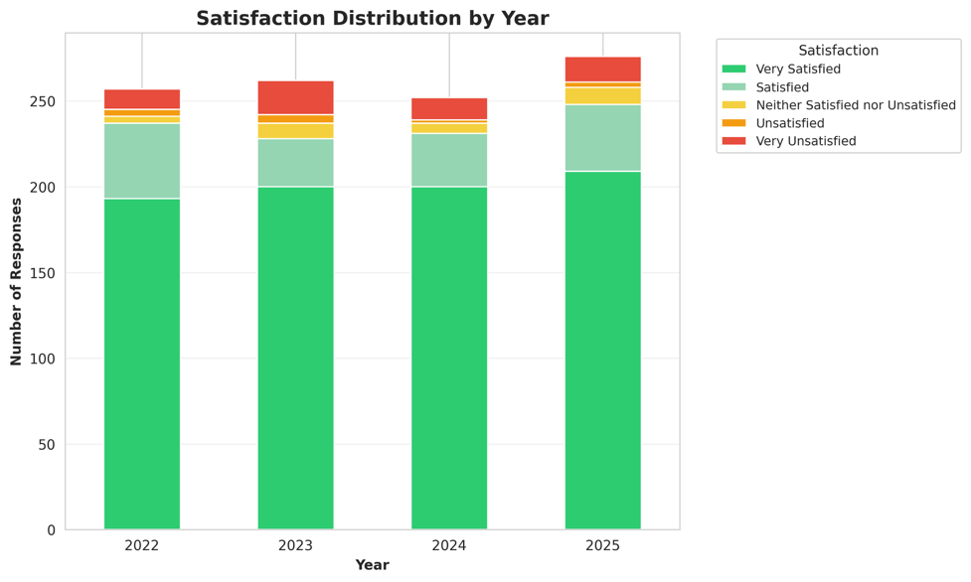
Figure 6. Satisfaction ratings by year.
Between 95% and 97% of respondents each year reported that Dempsey Center services made their life better. This was the most consistently positive finding across the entire dataset, with virtually no meaningful variation across years.
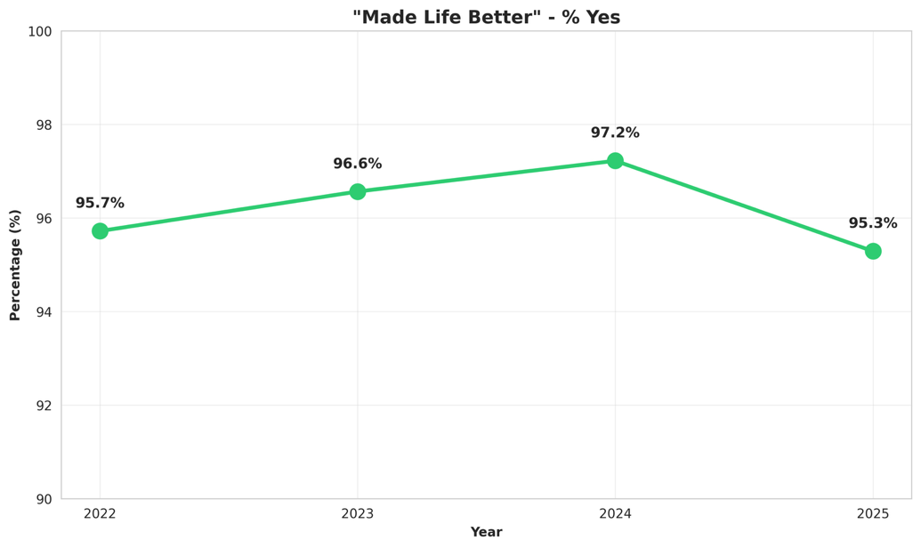
Figure 7. Proportion of respondents who reported services made their life better.
Service Utilization
The service frequency distribution remained broadly consistent year over year, with high-frequency usage (more than 10 times) dominating each year. 44.4% of respondents reported using services more than 10 times, while only 7% visited just once. This pattern suggests the center successfully retains clients beyond an initial visit, and that engagement levels have not shifted significantly despite modest growth in total respondents.
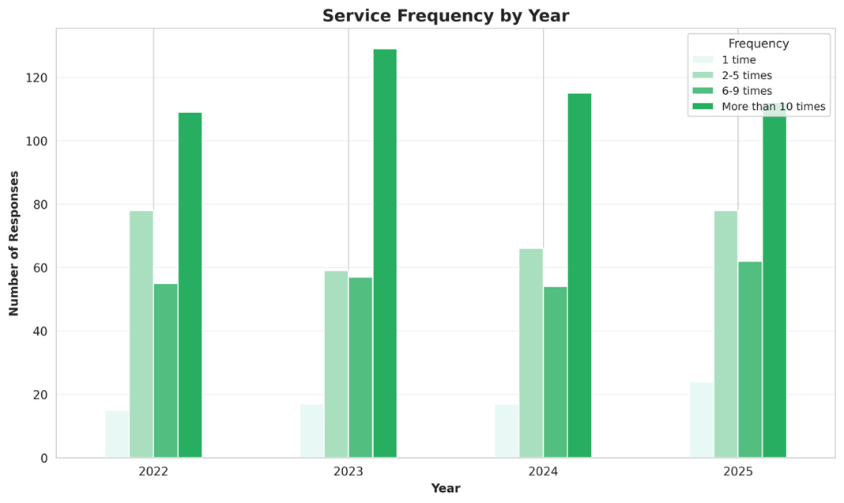
Figure 8. Service frequency distribution by year.
B. Statistical Tests
Three chi-square tests of independence were conducted to assess whether demographic and behavioral variables were associated with high satisfaction (defined as reporting "Very Satisfied").
Service frequency showed the strongest and most significant association with satisfaction (χ²=66.05, df=3, p<0.0001). The relationship follows a clear dose-response pattern: clients who visited more than 10 times reported high satisfaction at a rate of 86%, compared to only 49% among those who visited just once.
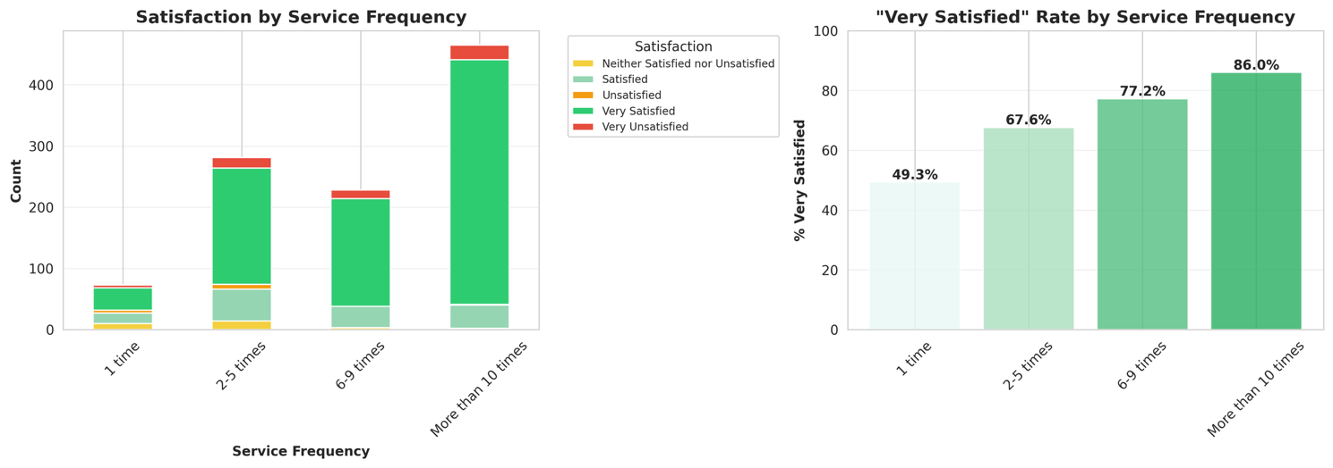Figure 9. High satisfaction rate by service frequency.
Age was also significantly associated with satisfaction (χ²=13.18, df=5, p=0.022). Clients aged 75 or older had the highest satisfaction rate at 84.7%, while the 25–34 group had the lowest at 62.5%. The general trend suggests older clients tend to report higher satisfaction, though sample sizes for younger age groups were small.
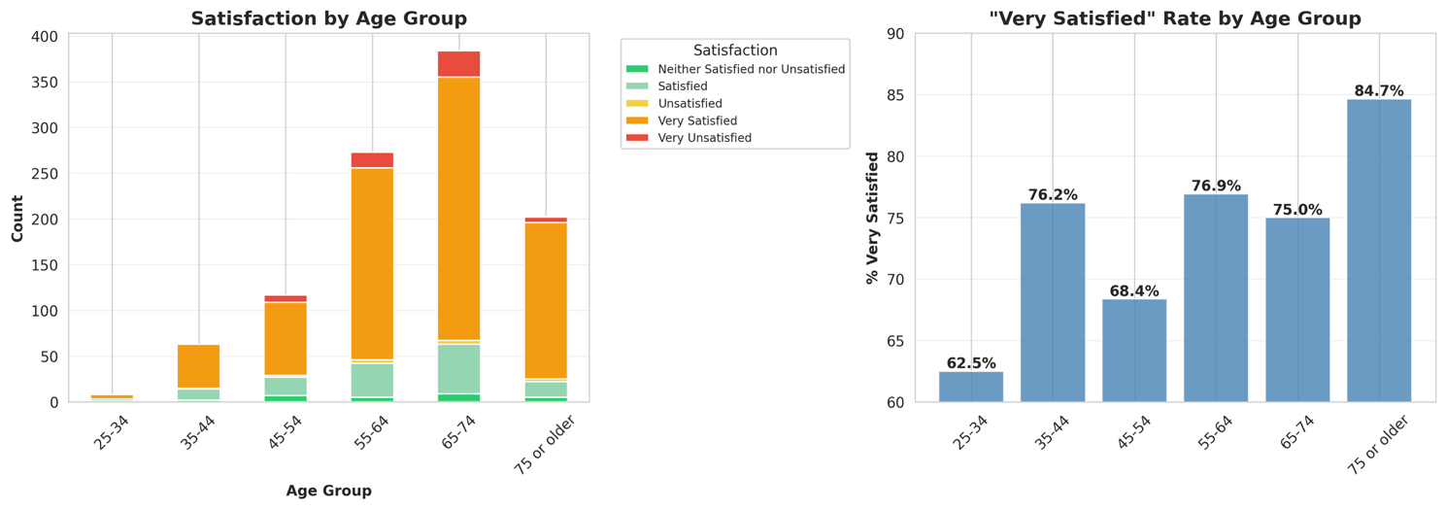Figure 10. High satisfaction rate by age group.
Cancer status was not significantly associated with satisfaction (χ²=7.73, df=5, p=0.172). Satisfaction rates were consistent across groups, ranging from 76.5% among current patients to 79.3% among survivors, suggesting that where a client is in their cancer journey does not meaningfully predict their satisfaction with Dempsey Center services.
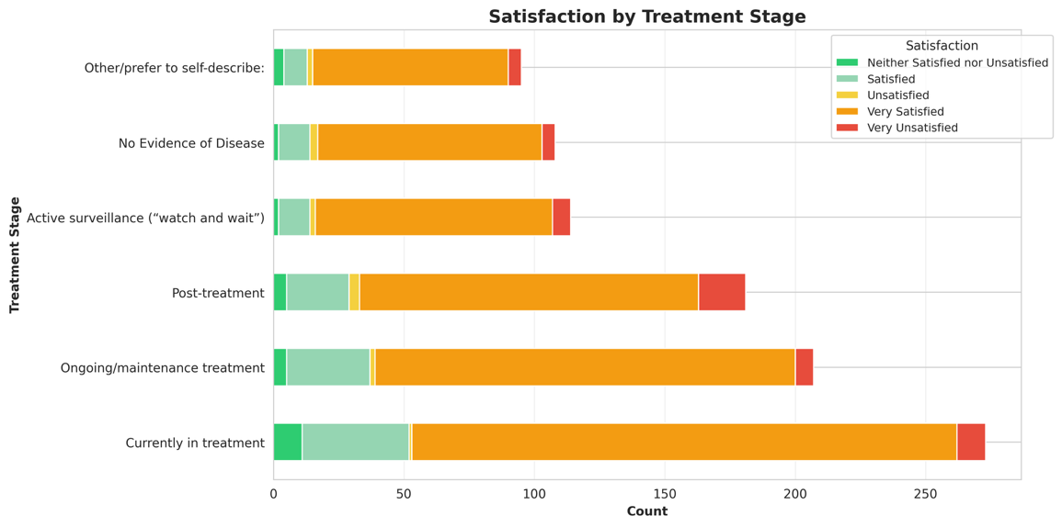
Figure 11. Treatment stage distribution.
Table 2 summarizes all three results.
Variable | χ² | df | p-value | Significant?
Service Frequency | 66.05 | 3 | <0.0001 | Yes
Age | 13.18 | 5 | 0.022 | Yes
Cancer Status | 7.73 | 5 | 0.172 | No
Table 2. Summary of chi-square test results.
C. Machine Learning Classification
We trained four classifiers to predict whether a client would report "Very Satisfied," using age, gender, service frequency, and cancer status as input features. Table 3 shows how each model performed on the held-out test set and under 5-fold cross-validation.
Model | Test Accuracy | CV Accuracy (±SD)
Gaussian Naive Bayes | 74.6% | 76.1% ± 1.4%
KNN (k=3) | 67.9% | 69.8% ± 2.9%
Decision Tree | 72.1% | 75.4% ± 1.3%
Random Forest | 72.1% | 75.6% ± 0.8%
Table 3. Model performance on test set and 5-fold cross-validation.
All four models performed in a fairly narrow range, which isn't surprising given that we only have four input features. Gaussian Naive Bayes ended up being the most reliable overall — it had the highest test accuracy (74.6%) and the highest CV accuracy (76.1%) with the tightest standard deviation (±1.4%), meaning it generalized consistently across folds rather than just getting lucky on one split. Decision Tree and Random Forest tied on test accuracy at 72.1%, though Random Forest had a slightly more stable CV performance (±0.8% vs ±1.3%). KNN lagged behind on both metrics and had the widest variance across folds (±2.9%), which suggests it struggled with the relatively small feature space.
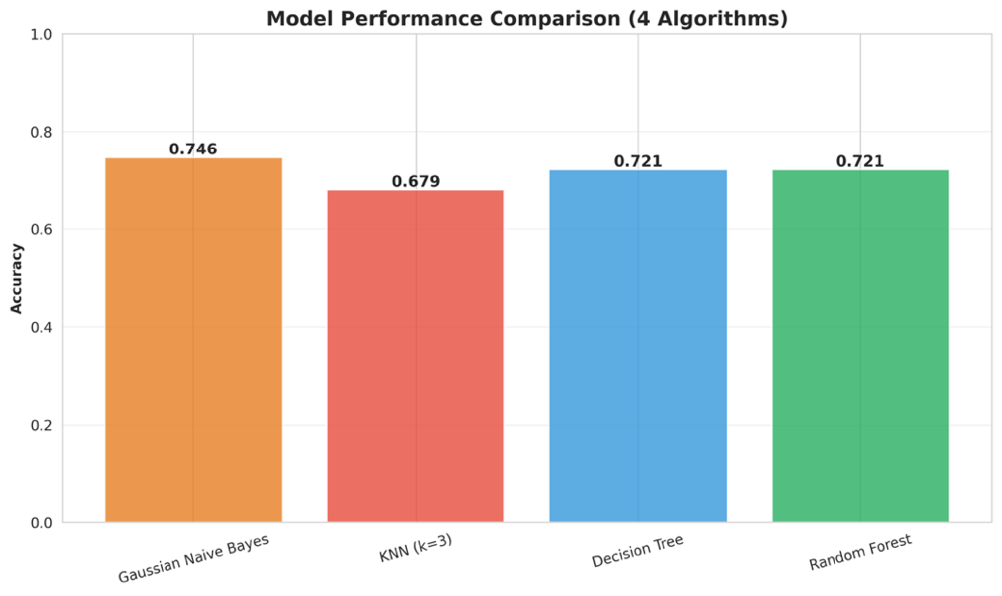
Figure 12. Model accuracy comparison across all four algorithms.
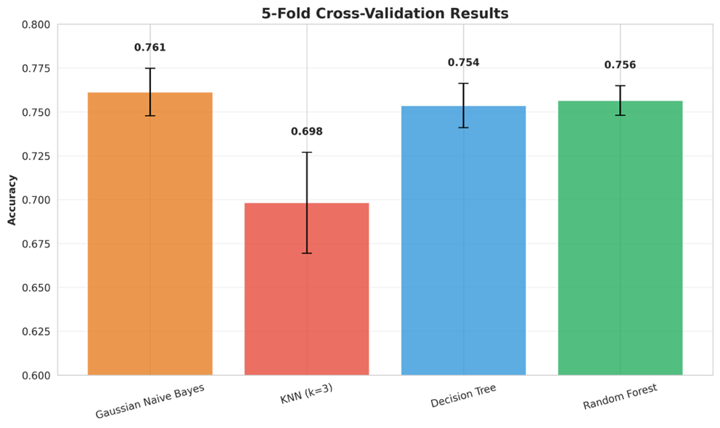
Figure 13. 5-fold cross-validation accuracy for each classifier.
D. Feature Importance Analysis
Both tree-based models ranked service frequency as the most important predictor by a significant margin — the Decision Tree gave it an importance score of 0.446, and Random Forest gave it 0.413. Age and cancer status each contributed at a secondary level — around 0.22–0.27 across both models — while gender was consistently the least important feature, scoring only 0.085–0.106.
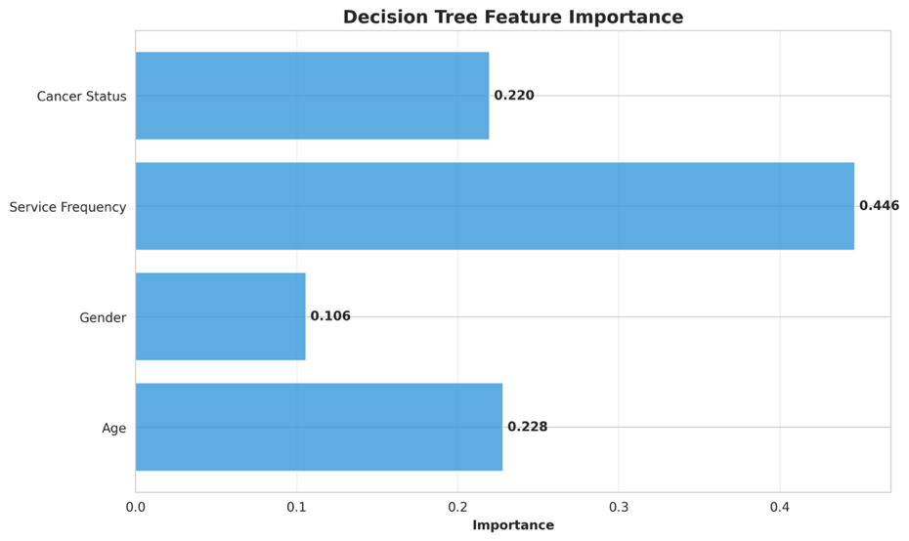
Figure 14. Decision Tree feature importance.
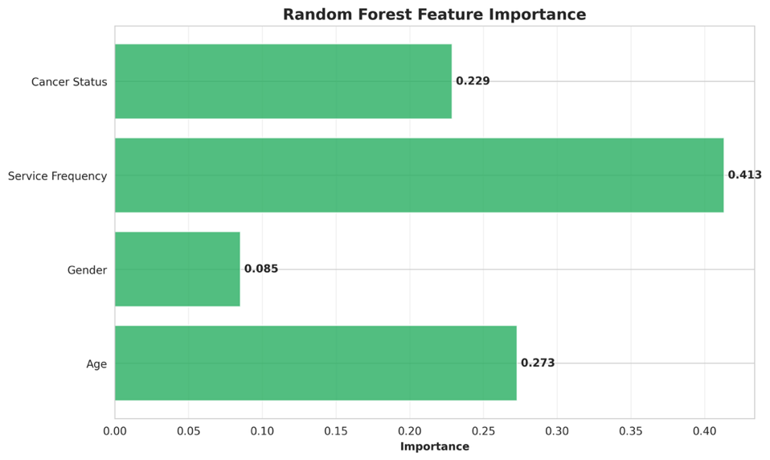
Figure 15. Random Forest feature importance.
This result lines up with everything else we found. The chi-square tests showed service frequency had the strongest association with satisfaction, the correlation analysis confirmed it had the highest r value, and now both tree models are independently arriving at the same conclusion. Gender being near the bottom also makes sense — with 81% of respondents being women, there just isn't enough variation in that variable for the models to learn much from it.
The dominance of service frequency over demographic variables like age and cancer status is worth highlighting for the Dempsey Center. It suggests that how often a client engages with services matters more than who they are. That's actually an actionable finding — the center can't change a client's age or cancer status, but it can design programs and outreach strategies that encourage people to come back more than once.
E. Confusion Matrices
Both confusion matrices show strong performance on the "Very Satisfied" class but very limited recall on the minority classes. The Decision Tree correctly classified 220 out of 232 Very Satisfied cases, but only identified 7 out of 83 non-Very-Satisfied cases. Random Forest performed similarly, correctly classifying 224 Very Satisfied cases but catching only 3 of the 83 non-satisfied ones. This is expected — with 76% of responses falling in the "Very Satisfied" category, the models naturally lean toward predicting the majority class. In practice, both models are better at identifying satisfied clients than flagging dissatisfied ones, which is a known limitation of working with imbalanced datasets.
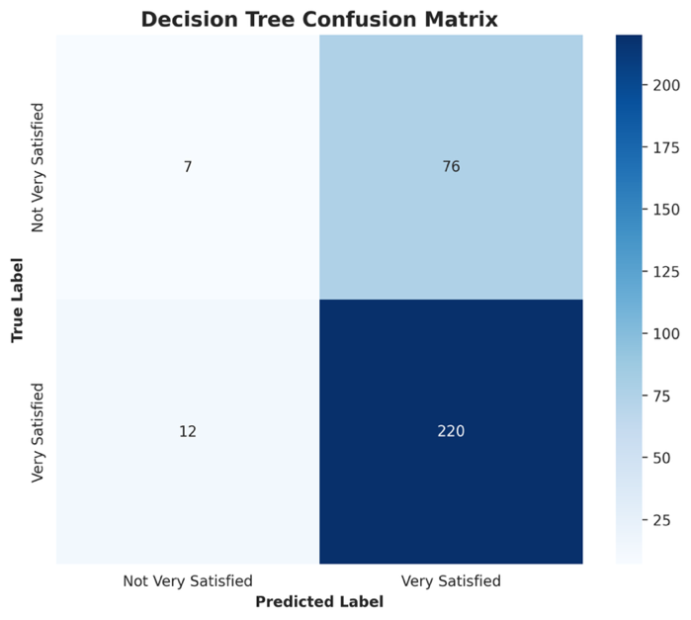
Figure 16. Decision Tree confusion matrix.
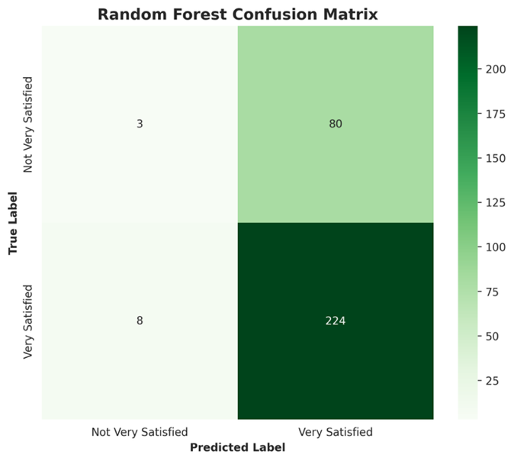
Figure 17. Random Forest confusion matrix.
F. Clustering Analysis
To identify distinct client segments, we applied K-means clustering using age, service frequency, and cancer status as input features. We left out gender since 81% of respondents were women — there wasn't enough variation for it to meaningfully differentiate groups. The elbow plot showed inertia dropping steeply from k=1 to k=4 and flattening out after that, so we went with k=4.
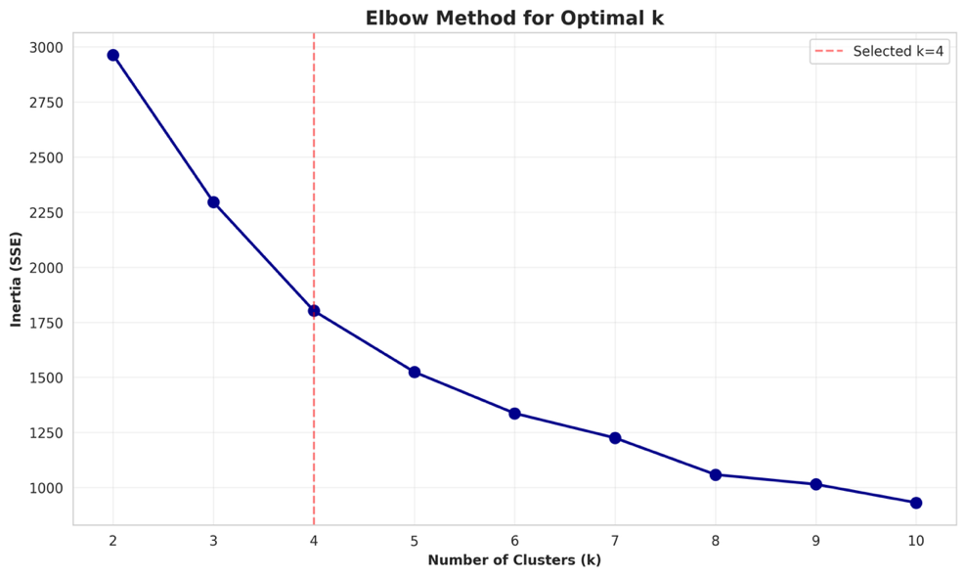
Figure 18. Elbow plot for K-means cluster selection.
The four clusters broke down as follows:
Cluster 3 was the largest group (n=433) and had the highest satisfaction rate at 85.5%. This cluster was made up mostly of older clients — 222 were in the 65–74 range and 122 were 75 or older — and nearly all of them were high-frequency users, with 332 reporting more than 10 visits. This is the center's core engaged population: older, loyal, and very satisfied.
Cluster 1 (n=281) had the lowest satisfaction rate at 65.1% and is the most concerning group from a programmatic standpoint. The frequency distribution here skewed heavily toward lower usage — 181 clients visited only 2–5 times and 56 visited just once. Age was mixed, with a concentration in the 55–64 and 65–74 groups. These clients are coming in but not returning, and their satisfaction reflects that.
Cluster 2 (n=187) was the youngest cluster, centered around 45–54 and 35–44 year olds, with moderate frequency usage and a 73.8% satisfaction rate. This group likely has different needs than the older majority, and the slightly lower satisfaction rate may reflect a mismatch between current offerings and what younger working-age clients are looking for.
Cluster 0 (n=146) also consisted largely of older, high-frequency users — the most common age was 65–74 and the most common frequency was more than 10 times — but had a notably lower satisfaction rate at 76.0% compared to Cluster 3. This suggests that frequency alone doesn't guarantee high satisfaction for this group, and there may be other unobserved factors at play.
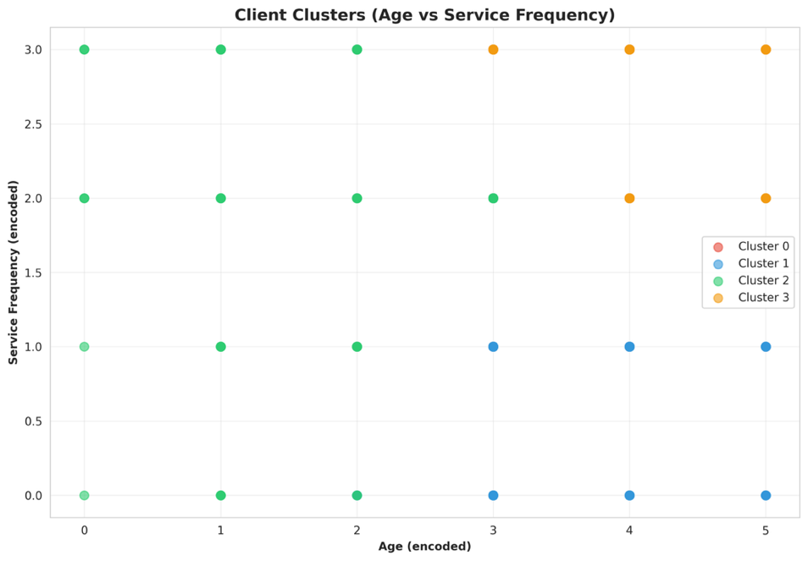
Figure 19. Cluster visualization.
G. PCA Results
PCA was run on all four encoded features after standardizing them to mean 0 and standard deviation 1. The first three principal components together explained 81.5% of the total variance — PC1 accounted for 31.0%, PC2 for 26.2%, and PC3 for 24.3%.
Looking at the component loadings, PC1 was driven primarily by age and gender in opposite directions (loadings of −0.667 and +0.668 respectively), capturing a demographic contrast between older and younger clients. PC2 was dominated by cancer status (loading of 0.912), isolating variation related to clients' relationship to cancer as its own distinct dimension. PC3 reflected service frequency most strongly (loading of 0.938), separating high-frequency from low-frequency users independently of demographics.
The fact that service frequency loads heavily onto its own principal component — rather than correlating with age or cancer status — suggests it really is capturing something distinct about client behavior that isn't just a proxy for who the client is.
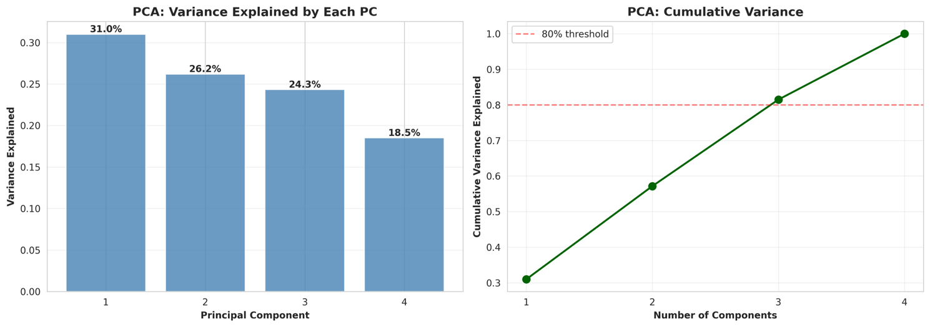
Figure 20. PCA scree plot and component loadings.
H. Correlation Analysis
The Pearson correlation heatmap confirmed that service frequency had the strongest linear relationship with high satisfaction (r=0.247). This is modest in absolute terms but consistent and meaningful given that we're working with categorical variables encoded as integers. Age showed a weak positive correlation (r=0.079), and gender and cancer status were essentially flat at r=−0.017 and r=−0.033 respectively — consistent with the chi-square finding that those two variables aren't meaningfully associated with satisfaction outcomes.
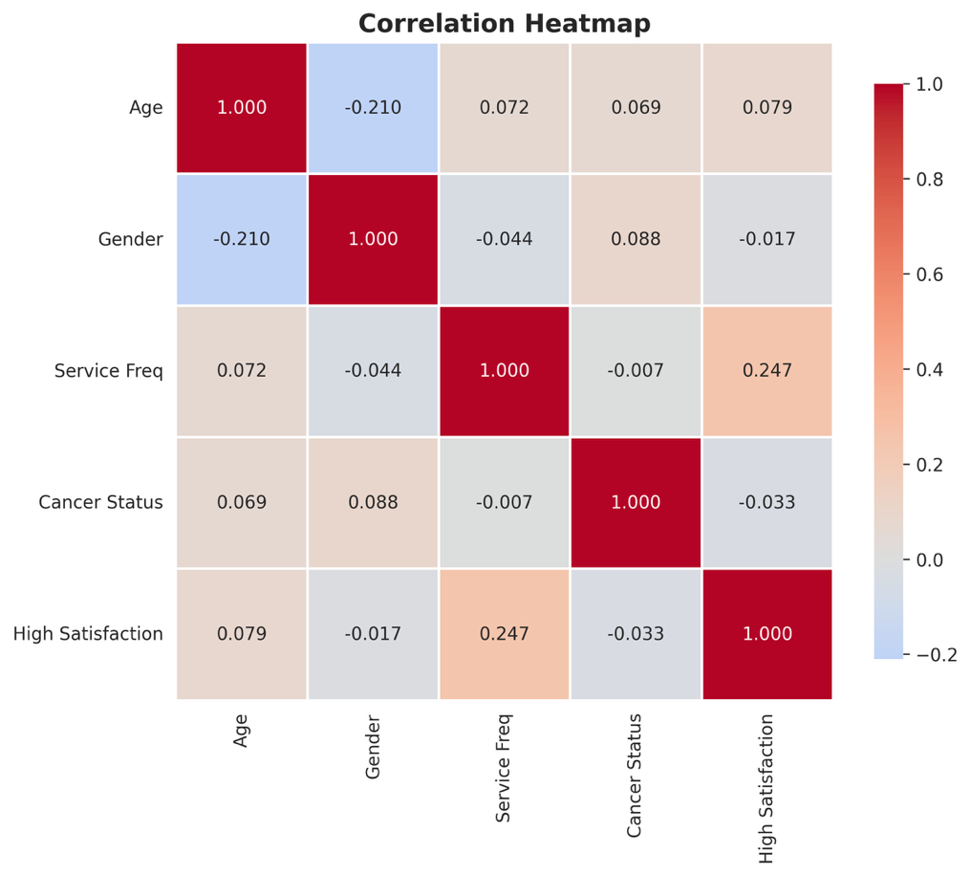
Figure 21. Pearson correlation heatmap.

Discussion
The clearest takeaway from this analysis is that service frequency is the single most important factor associated with client satisfaction, and it showed up that way across every method we used — chi-square tests, feature importance from both tree models, PCA, and correlation analysis all pointed to the same conclusion. Clients who visited more than 10 times were satisfied at nearly double the rate of one-time visitors. Whether that's because frequent engagement builds trust and familiarity, or because already-satisfied clients simply return more often, the practical implication is the same: getting clients to come back beyond their first visit matters a lot.
Age was the second most consistent factor. Older clients, especially those 75 and above, reported the highest satisfaction, while younger clients — particularly the 25–34 group — were the least satisfied and the most underrepresented in the data. This gap could reflect differences in what younger working-age adults need from a support service, or simply that the current program mix is better calibrated for older populations. Either way, it's worth paying attention to.
Cancer status not being significant is actually a reassuring finding. It means the center is serving current patients, survivors, care partners, and family members at roughly equal levels of effectiveness. The services aren't accidentally optimized for one group at the expense of others.
The clustering analysis added a useful layer to these findings. The contrast between Cluster 3 (older, high-frequency, 85.5% satisfied) and Cluster 1 (mixed age, low-frequency, 65.1% satisfied) suggests that the center's biggest opportunity isn't necessarily attracting new clients — it's converting low-engagement visitors into repeat ones. Cluster 2, the younger cluster, represents a different challenge: this group may need different types of programming or outreach to feel as well-served as the older majority.

Limitations
A few limitations are worth keeping in mind. First, the survey only captures clients who actively completed the annual questionnaire. People who had negative experiences or stopped using services altogether are unlikely to show up in the data, which probably inflates the overall satisfaction numbers.
Second, the survey instrument changed across the four years we studied, with column counts growing from 72 to 105. We manually verified the column positions for each variable, but some variables — like income and treatment stage — were only available for certain years and couldn't be included consistently across the full longitudinal analysis.
Third, the class imbalance in the outcome variable (76% "Very Satisfied") limited the classifiers' ability to detect dissatisfied clients. All four models performed well on the majority class but struggled with minority ones. Future work could apply resampling techniques like SMOTE to address this.
Finally, the features available to us were fairly limited — four demographic and behavioral variables. A richer feature set, including which specific services clients used or how long they had been attending, would likely improve both model accuracy and the depth of insights we could draw.

Future Work
The most valuable next step would be tracking individual clients across multiple years rather than treating each survey response as independent. Right now we can see that satisfaction is stable at the population level, but we can't tell whether individual clients' experiences are improving, declining, or staying the same over time. A longitudinal client-level dataset would answer that question directly.
It would also be worth investing in outreach to low-engagement clients — particularly the Cluster 1 profile — to understand why they didn't return after one or two visits. Exit surveys or targeted follow-ups could surface barriers that the annual satisfaction survey isn't designed to capture.
On the analysis side, applying NLP to open-ended survey responses could reveal themes and pain points that structured questions miss. And as noted above, resampling methods like SMOTE could help the classification models perform better on dissatisfied clients, who are arguably the most important group to identify correctly.

References
Dempsey Center. (2025). About the Dempsey Center. https://www.dempseycenter.org/about/

American Cancer Society. (2025). Therapy, counseling, and support resources for people with cancer. https://www.cancer.org/cancer/survivorship/coping/understanding-psychosocial-support-services.html

Gao, Y., et al. (2024). Global unmet psychosocial needs in cancer care: Health policy. eClinicalMedicine. https://doi.org/10.1016/j.eclinm.2024.102855

Sautier, L., et al. (2021). Evaluations of psychosocial cancer support services: A scoping review. PLOS ONE. https://doi.org/10.1371/journal.pone.0251126

